CD CODE

*def* first(*c*, *prods*, *fs*):

    if *c* not in *fs*: *fs*[*c*] = set()

    if *c*.islower():

*fs*[*c*].add(*c*)

         return *fs*[*c*]

    for prod in *prods*.get(*c*, []):

        if prod == '#': *fs*[*c*].add('#')

        elif prod[0].islower():

*fs*[*c*].add(prod[0])

        else:

            for char in prod:

                res = first(char, *prods*, *fs*)

*fs*[*c*].update(res - {'#'})

                if '#' not in res:

                    break

                if char == prod[-1]:

*fs*[*c*].add('#')

    return *fs*[*c*]

*def* follow(*c*, *start*, *prods*, *fs*, *follows*):

    if *c* not in *follows*:

*follows*[*c*] = set()

    if *c* == *start*:

*follows*[*c*].add('$')

    for head, rules in *prods*.items():

        for prod in rules:

            if *c* in prod:

                idx = prod.index(*c*)

                if idx == len(prod) - 1:

                    if head != *c*:

*follows*[*c*].update(follow(head, *start*, *prods*, *fs*, *follows*))

                else:

                    next_sym = prod[idx + 1]

                    next_first = first(next_sym, *prods*, *fs*)

*follows*[*c*].update(next_first - {'#'})

                    if '#' in next_first:

*follows*[*c*].update(follow(head, *start*, *prods*, *fs*, *follows*))

    return *follows*[*c*]

*def* main():

    prods = {'S': ['ABC'],

              'A': ['DEF'],

                'B': ['#'],

                'C': ['#'],

                'D': ['#'],

                'E': ['#']

            }

    start = 'S'

    first_sets, follow_sets = {}, {}

    print("Grammar:")

    for nt, rules in prods.items():

        print(*f*"{nt} -> {' | '.join(rules)}")

    for nt in prods:

        first(nt, prods, first_sets)

    for nt in prods:

        follow(nt, start, prods, first_sets, follow_sets)

    print("\nFirst Sets:")

    for nt, fs in first_sets.items():

        if nt.isupper():

            print(*f*"First({nt}) = {fs}")

    print("\nFollow Sets:")

    for nt, fs in follow_sets.items():

        print(*f*"Follow({nt}) = {fs}")

if __name__ == "__main__": main()

OUTPUT :

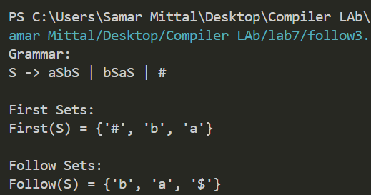 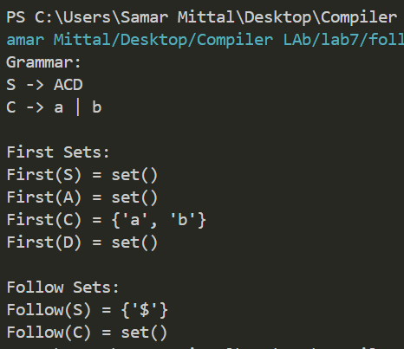

TEST CASE 2

TEST CASE 1

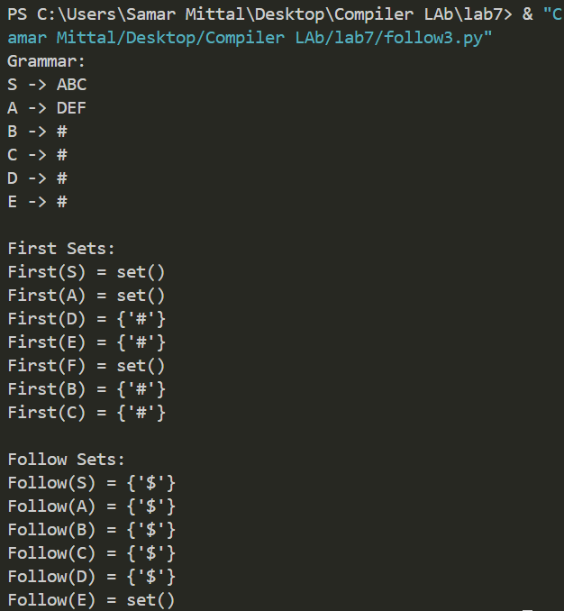 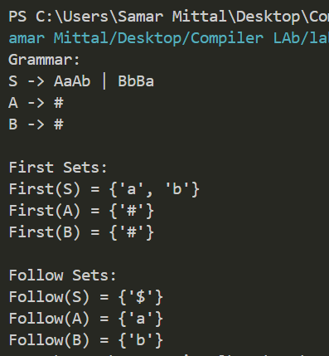

TEST CASE 4

TEST CASE 3